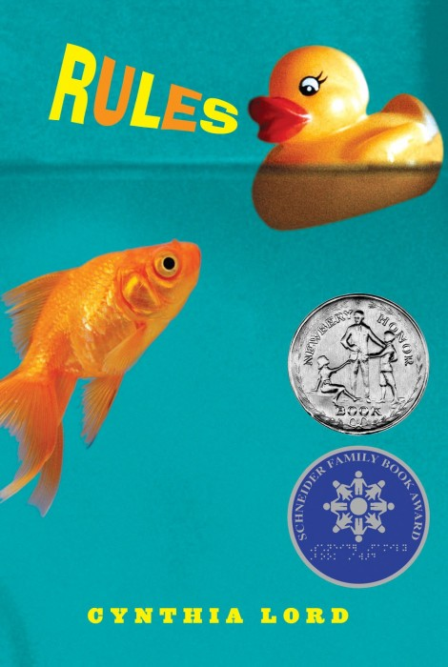
Name #________________________________
Date__________________

Rules by Cynthia Lord

We just finished our first novel study on the story Rules. You need to choose a minimum of three (3) of the following choices. The completed assignment is due on: _____________________________.

Six word summary  Write a 6 word summary of rules. You may NOT use the words, Catherine, David, Jason, Rules, Autism in your summary | Found Poem  Create a found poem using the actual words of the text. Your poem should try to capture the emotion of the scene. | Create 6 rule cards to add to Jason’s book  Imagine that Jason was coming to Live Oak, what 6 words would he need in his communication book to be successful? Design colorful cards that would be added to his book.
Rules of Rules  Catherine wrote many rules throughout the story. Choose two (2) rules and explain the significance of the rule to Catherine and/or David. | Character Map of Catherine  Design a character map of Catherine. Choose 5 character traits that describe her. Use text evidence to support each trait. | Movie Poster  Imagine that Rules was going to be turned into a movie. Design a movie poster showing the title, author, and some sort of image or graphic to give a hint to the plot.
Ability awareness project  We learned a but about autism and special needs through our study of Rules. Research and design an informational brochure on a different ability. | Create a Wordle  Choose 3 characters from the novel. (word map) showing the character’s traits, items that are important to them, important events. | Free Choice.  Come up with a different idea. Must be teacher approved before you begin.

All assignments need to be thoughtfully and neatly completed. You will be evaluated on the effort you display for each assignment. It is encouraged that you type up your work, but it is not required. You will be given some class time to work on these assignments, but ultimately it is your responsibility to make sure you complete the assignment.

