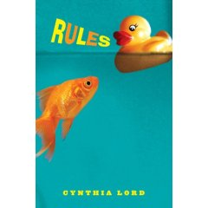
Rules by Cynthia Lord
Word Cards for Jason

Jason is a character from Rules. He is not able to communicate verbally. So instead, he has a communication book with many words that help him get his ideas and thoughts across to people.

If Jason were to join our classroom right now and become the newest member of our class, what words would he need in order to be successful? Think of 6 words that would help him be able to communicate with his classmates, teacher and other members of our school.

Each card should have: (1) an important word or phrase; (2) a picture, design or other symbol that relates to the cards; and (3) a description of why that word would help him in our class.

Front side (solid): Back Side (lines):
Libray

Description: 2-4 sentences of WHY this is an important word/phase.

Word or phrase
&
Picture

You will be graded on your word or phrase choice, the variety of words or phrases you gave him, the presentation of the card, as well as the description on the back explaining the significance of the word or phrase. See the rubric below to help you make sure you are doing your best work.

Word/Phrase | Word/Phrase Choice: Specific word choice? Relevant to assignment topic | Presentation: Is the work neat? Clearly written, colorfully decorated? Picture makes sense? | Description: Sentences answer and explain why the word/phrase is necessary | Points Received
 |  |  |  | /10
 |  |  |  | /10
 |  |  |  | /10
 |  |  |  | /10
 |  |  |  | /10

Total Points _________/ 60

